TASK 1
You should spend about 20 minutes on this task. Write at least 150 words.
After you finish, use the checklist to evaluate your writing task. Then, compare your task with the sample answer.

The graph below gives information about the sales of the three most commonly purchased items in a particular bakery for the year 2014.
Summarise the information by selecting and reporting the main features, and make comparisons where relevant.
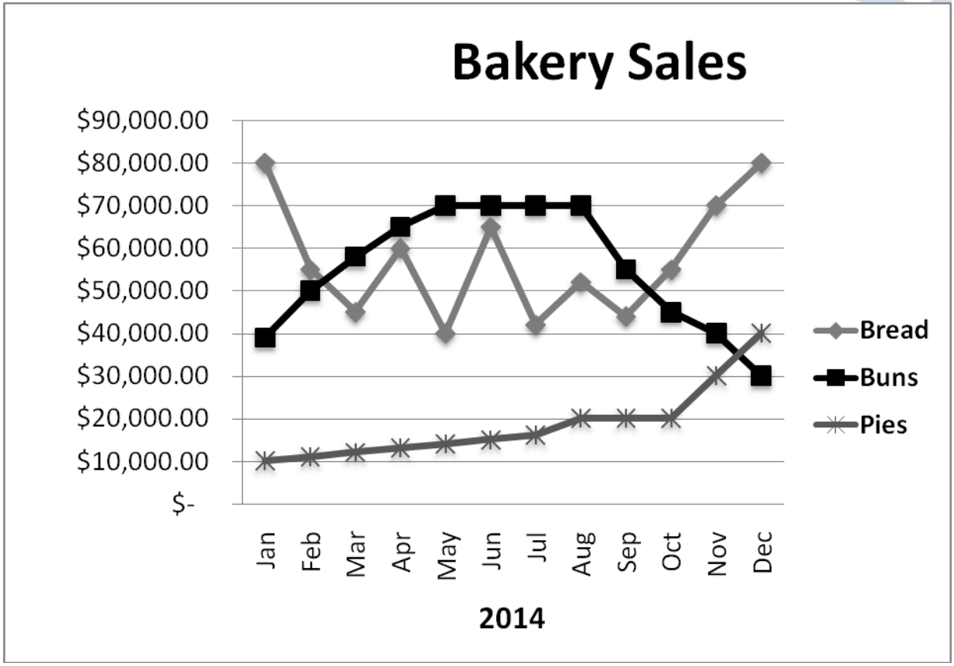

TASK 2
You should spend about 40 minutes on this task. Write at least 250 words
After you finish, use the checklist to evaluate your writing task. Then, compare your task with the sample answer.

Write about the following topic: The internet has changed the way we communicate. Much communication today happens through social media. Some people support this and think it is a positive development. Others believe that social media have negative effects.
Discuss both these views and give your own opinion.
Give reasons for your answer and include any relevant examples from your own knowledge or experience.

